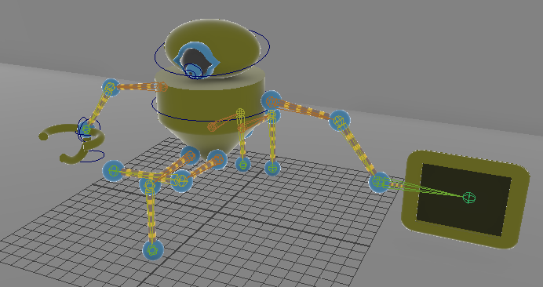

The robot is in thinking mode, thinking about what it wants to code.

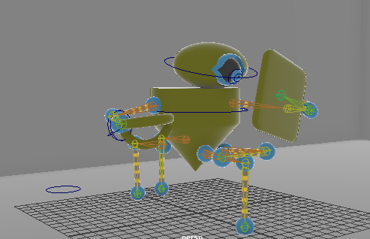

The robot is looking at its computer screen. Obviously looking at the code it wrote.

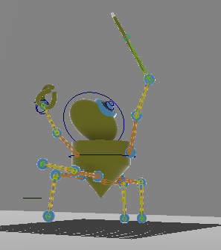

The robot raises its arms as it gets fed up with some bugs in the code. Apparently, some very nasty, persistent, annoying bugs.

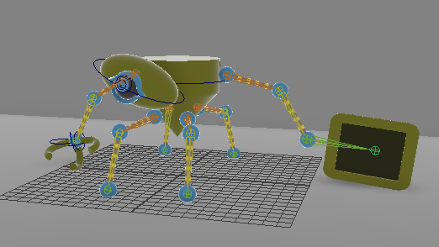

The bored robot is giving off a deadpan stare as the robot it created continues to malfunction.

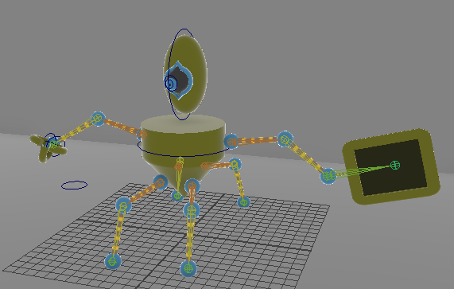

A new idea suddenly comes to the robot. “Hey! I got an idea!”